**E**

**PRIME NUMBER OR NOT**

**EX.NO : 01 010101**

**DATE :**

**AIM:**

To write a php program to check the given number is prime number or not.

**ALGORITHM:**

**Step 1:** Start the process

**Step 2:** Write the html5 program and create a form using text area and button control it performs the form action.

**Step 3:** When we click our button control it performs the form action.

**Step 4:** Write a php code and create a primenumber.php file

**Step 5:** Check if the given number is prime or not.

$flag=1;

for($i=2;$i<$v;$i++)

{

if($v%$i==0){

$flag = 0;

break;

}

}

**Step 6:** Save this program in the name of primenumber.php and run using any web browser.

**Step 7:** Stop the process.

**form.html**

<!DOCTYPE html>

<html lang="en">

<head>

<meta charset="UTF-8">

<meta name="viewport" content="width=device-width, initial-scale=1.0">

<title>Prime Number</title>

<style>

.Heading{

display: flex;

flex-direction: column;

align-items: center;

margin-top: 200PX;

}

button{

align-items: center;

justify-content: center;

margin-left: 120px;

margin-top: 20px;

}

</style>

</head>

<body>

<div class="Heading">

<h1>Prime Number</h1>

<form action="primeNumber.php" method="post">

<label for="number">Enter the Number : </lable>

<input type = "text" name="number">

<br>

<button onClick="primeNumber.php">Click Me</button>

</form>

</div>

</body>

</html>

**primeNumber.php**

<?php

$v=$_POST["number"];

$flag=1;

for($i=2;$i<$v;$i++)

{

if($v%$i==0){

$flag = 0;

break;

}

}

if($flag == 1)

echo $v." is Prime Numbers ";

else

echo $v." is Not Prime Numbers ";

?>

**Output:**

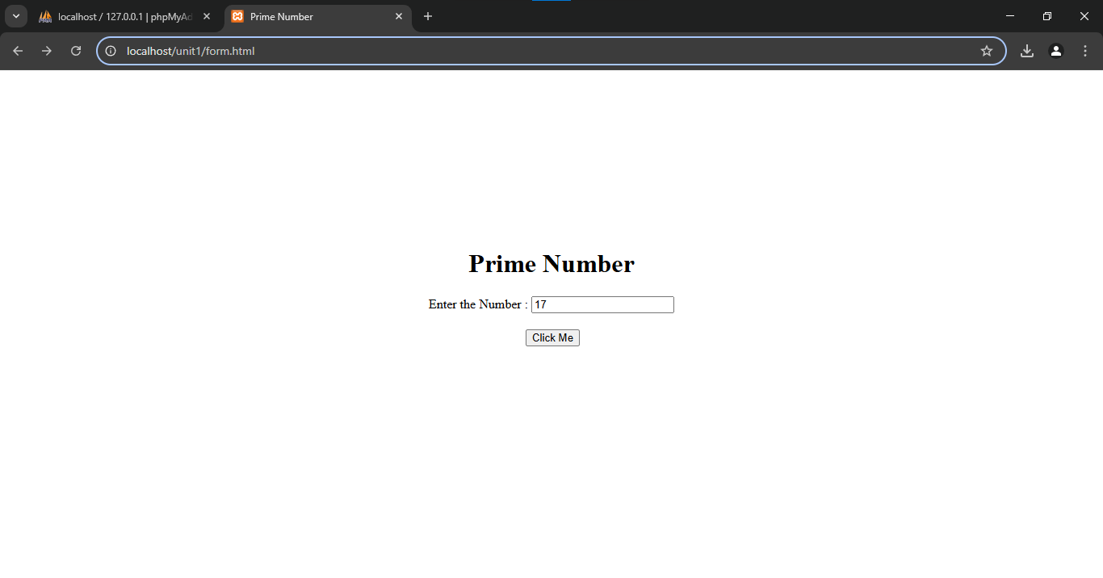

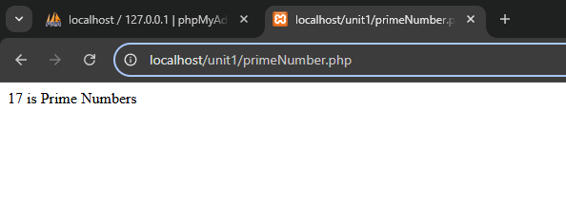

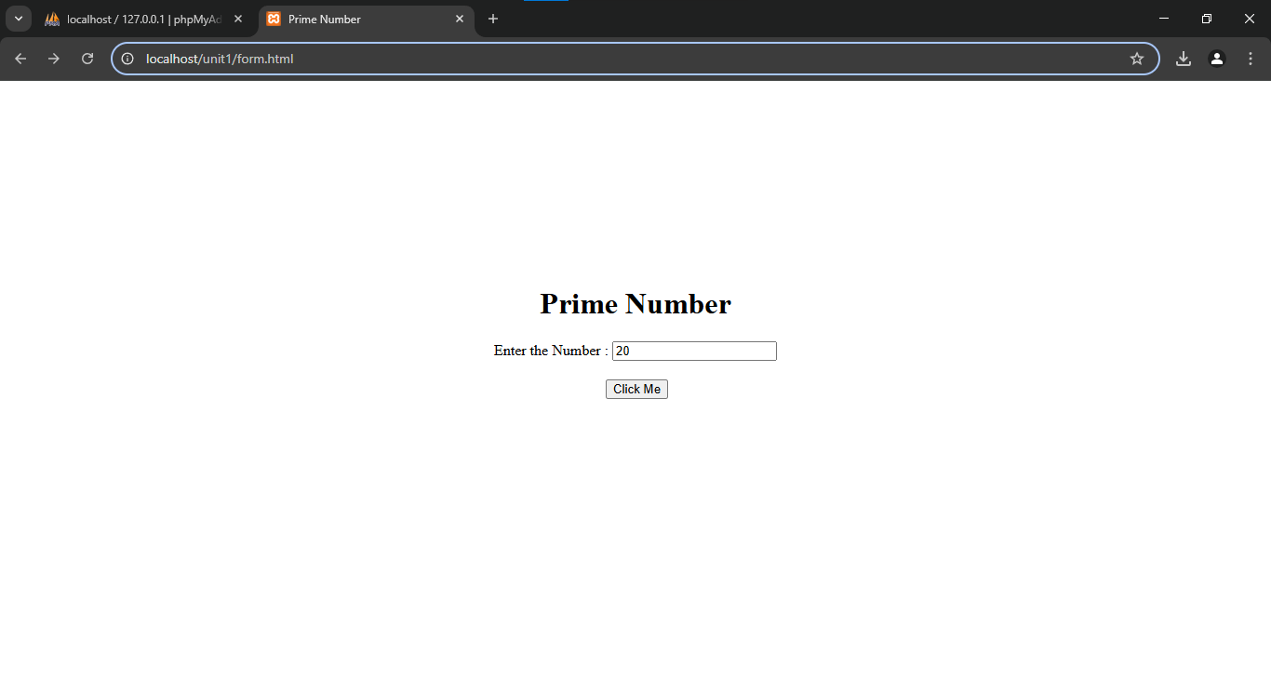

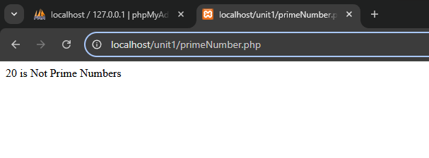

**Result:**

Thus, our program has been successfully saved and executed.

**DATE :**

**EX.NO : 02 010101**

**GENERATE PRIME NUMBER**

**AIM:**

To write a php program to generate the prime number upto the given number

**ALGORITHM:**

**Step 1:** Start the process

**Step 2:** Write the html5 program and create a form using text area and button control it performs the form action.

**Step 3:** When we click our button control it performs the form action.

**Step 4:** Write a php code and create a generatePrimeNumber.php file

**Step 5:** Check if the sequence of number is prime then print.

for($i=2;$i<=$v;$i++)

{

$flag=1;

for($j=2;$j<$i;$j++){

if($i % $j == 0){

$flag = 0;

break;

}

}

if($flag == 1){

echo $i." is Prime Numbers ";

echo "<br>";

}

}

**Step 6:** Save this program in the name of generatePrimeNumber.php and run using any web browser.

**Step 7:** Stop the process.

**form.html**

<!DOCTYPE html>

<html lang="en">

<head>

<meta charset="UTF-8">

<meta name="viewport" content="width=device-width, initial-scale=1.0">

<title>Generate Of Prime Number</title>

<style>

.Heading{

display: flex;

flex-direction: column;

align-items: center;

margin-top: 200PX;

}

button{

align-items: center;

justify-content: center;

margin-left: 120px;

margin-top: 20px;

}

</style>

</head>

<body>

<div class="Heading">

<h1>Generate Of Prime Number</h1>

<form action="generatePrimeNumber.php" method="post">

<label for="number">Enter the Number : </lable>

<input type = "text" name="number">

<br>

<button onClick="generatePrimeNumber.php">Click Me</button>

</form>

</div>

</body>

</html>

**generateprimeNumber.php**

<?php

$v=$_POST["number"];

for($i=2;$i<=$v;$i++)

{

$flag=1;

for($j=2;$j<$i;$j++){

if($i % $j == 0){

$flag = 0;

break;

}

}

if($flag == 1){

echo $i." is Prime Numbers ";

echo "<br>";

}

}

?>

**Output:**

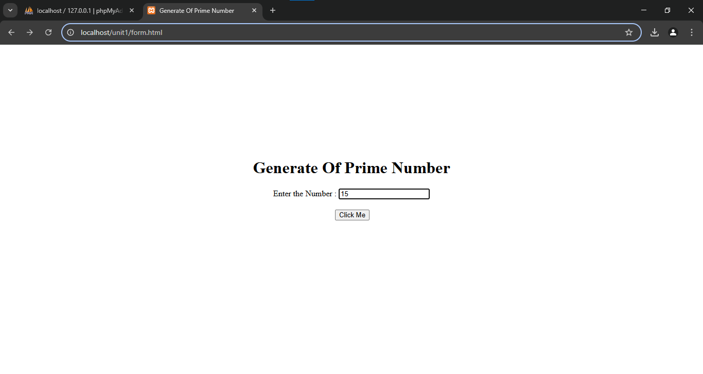 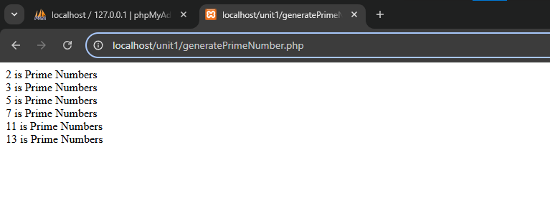

**Result:**

Thus, our program has been successfully saved and executed.

**DATE :**

**EX.NO : 03 010101**

**PERFECT NUMBERS**

**AIM:**

To write a php program to check the given number is perfect number or not

**ALGORITHM:**

**Step 1:** Start the process

**Step 2:** Write the html5 program and create a form using text area and button control it performs the form action.

**Step 3:** When we click our button control it performs the form action.

**Step 4:** Write a php code and create a PerfectNumber.php file

**Step 5:** Check if the given number is perfect number or not.

$sum=1;

for($i=2;$i<$v;$i++){

if($v%$i==0){

$sum = $sum + $i;

}

}

if($sum==$v){

echo $v." is Perfect Number ";

echo "<br>";

}

else{

echo $v." is Not Perfect Number ";

echo "<br>";

}

**Step 6:** Save this program in the name of PerfectNumber.php and run using any web browser.

**Step 7:** Stop the process.

**form.html**

<!DOCTYPE html>

<html lang="en">

<head>

<meta charset="UTF-8">

<meta name="viewport" content="width=device-width, initial-scale=1.0">

<title>Perfect Number</title>

<style>

.Heading{

display: flex;

flex-direction: column;

align-items: center;

margin-top: 200PX;

}

button{

align-items: center;

justify-content: center;

margin-left: 120px;

margin-top: 20px;

}

</style>

</head>

<body>

<div class="Heading">

<h1>Perfect Number </h1>

<form action="PerfectNumber.php" method="post">

<label for="number">Enter the Number : </lable>

<input type = "text" name="number">

<br>

<button onClick="PerfectNumber.php">Click Me</button>

</form>

</div>

</body>

</html>

**PerfectNumber.php**

<?php

$v=$_POST["number"];

$sum=1;

for($i=2;$i<$v;$i++){

if($v%$i==0){

$sum = $sum + $i;

}

}

if($sum==$v){

echo $v." is Perfect Number ";

echo "<br>";

}

else{

echo $v." is Not Perfect Number ";

echo "<br>";

}

?>

**Output:**

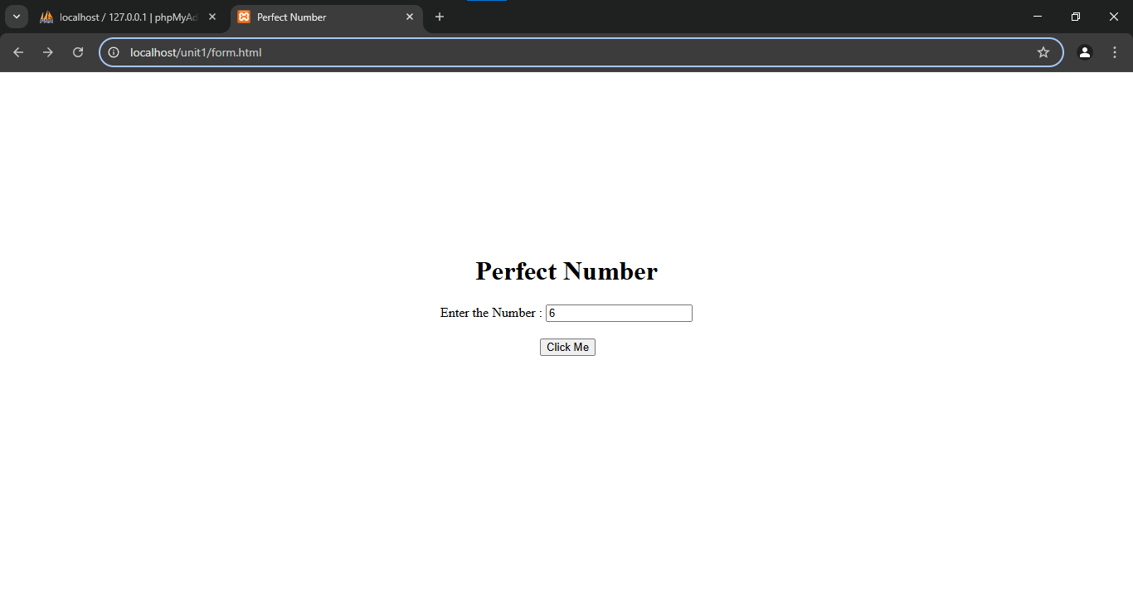

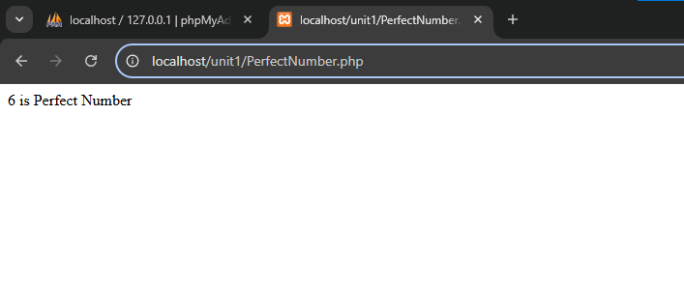

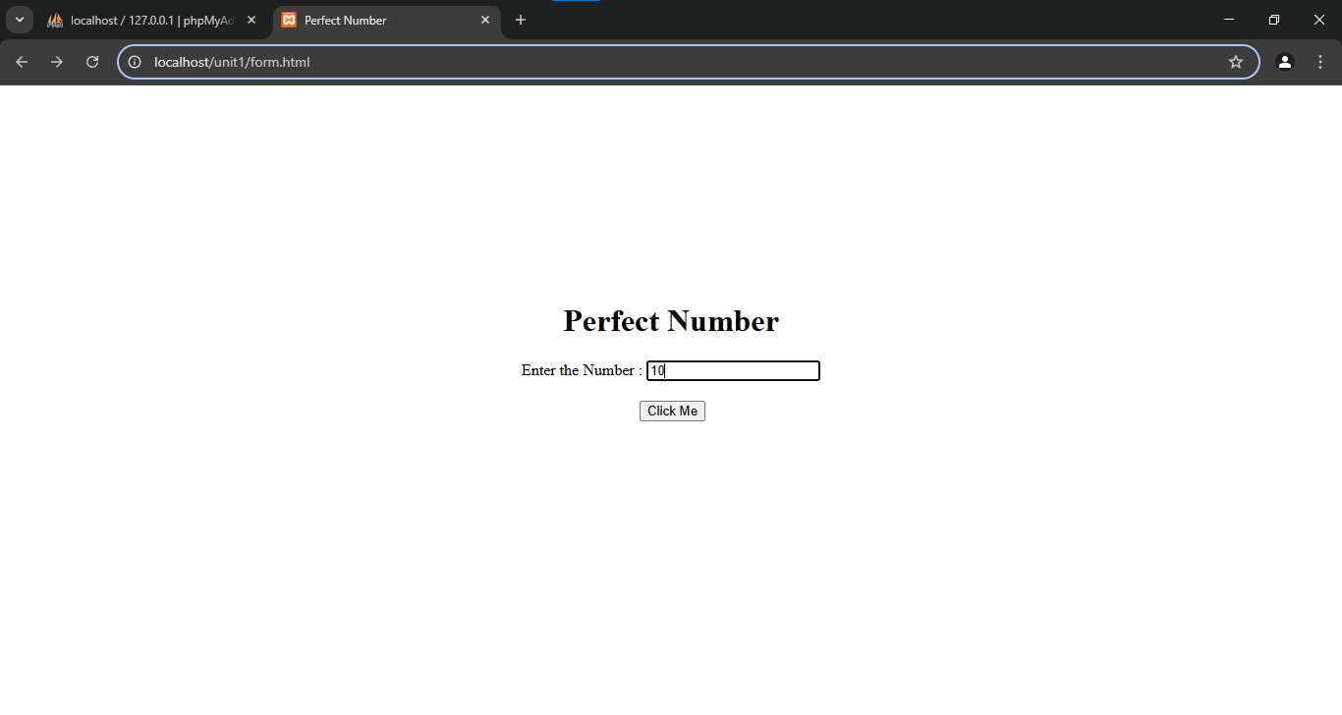

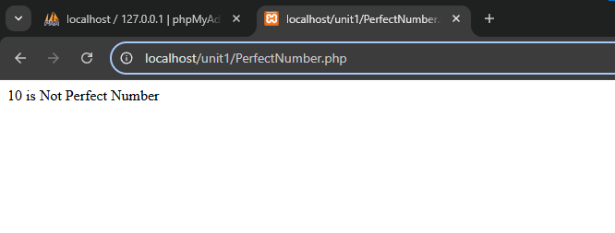

**Result:**

Thus, our program has been successfully saved and executed.

**GENERATE PERFECT NUMBERS**

**EX.NO : 04 010101**

**DATE :**

**AIM:**

To write a php program to generate the perfect number upto the given number

**ALGORITHM:**

**Step 1:** Start the process

**Step 2:** Write the html5 program and create a form using text area and button control it performs the form action.

**Step 3:** When we click our button control it performs the form action.

**Step 4:** Write a php code and create a GeneratePerfectNumber.php file

**Step 5:** To generate perfect number upto the given number.

for($j=2;$j<=$v;$j++)

{

$sum=1;

for($i=2;$i<$j;$i++){

if($j%$i==0){

$sum = $sum + $i;

}

}

if($sum==$j){

echo $j." is Perfect Number ";

echo "<br>";

}

}

**Step 6:** Save this program in the name of GeneratePerfectNumber.php and run using any web browser.

**Step 7:** Stop the process.

**form.html**

<!DOCTYPE html>

<html lang="en">

<head>

<meta charset="UTF-8">

<meta name="viewport" content="width=device-width, initial-scale=1.0">

<title>Perfect Number</title>

<style>

.Heading{

display: flex;

flex-direction: column;

align-items: center;

margin-top: 200PX;

}

button{

align-items: center;

justify-content: center;

margin-left: 120px;

margin-top: 20px;

}

</style>

</head>

<body>

<div class="Heading">

<h1>Generate Perfect Number</h1>

<form action="GeneratePerfectNumber.php" method="post">

<label for="number">Enter the Number : </lable>

<input type = "text" name="number">

<br>

<button onClick="GeneratePerfectNumber.php">Click Me</button>

</form>

</div>

</body>

</html>

**GeneratePerfectNumber.php**

<?php

$v=$_POST["number"];

for($j=2;$j<=$v;$j++)

{

$sum=1;

for($i=2;$i<$j;$i++){

if($j%$i==0){

$sum = $sum + $i;

}

}

if($sum==$j){

echo $j." is Perfect Number ";

echo "<br>";

}

}

?>

**Output:**

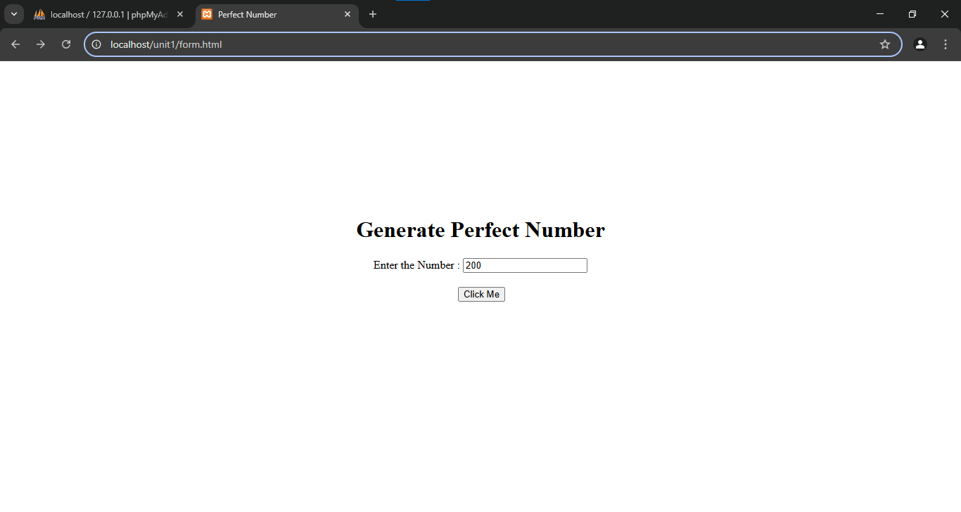

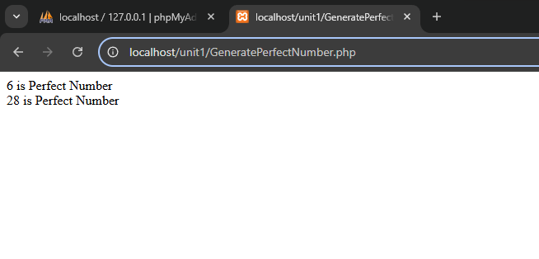

**Result:**

Thus, our program has been successfully saved and executed.

**DATE :**

**EX.NO : 05 010101**

**ARM STRONG**

**AIM:**

To write a php program to check the given number is Arm Strong number or not

**ALGORITHM:**

**Step 1:** Start the process.

**Step 2:** Write the html5 program and create a form using text area and button control it performs the form action.

**Step 3:** When we click our button control it performs the form action.

**Step 4:** Write a php code and create a Armstrong.php file

**Step 5:** To check thethe given number is Armstrong Number or not.

$c=$v;

$r = 0;

$sum = 0;

while($v>0){

$r = $v % 10;

$sum = $sum + ( $r * $r * $r);

$v = $v / 10;

}

if($c==$sum){

echo $c." Is Arm strong Number";

}

else{

echo $c." Is Not an Arm strong Number";

}

**Step 6:** Save this program in the name of Armstrong.php and run using any web browser.

**Step 7:** Stop the process.

**form.html**

<!DOCTYPE html>

<html lang="en">

<head>

<meta charset="UTF-8">

<meta name="viewport" content="width=device-width, initial-scale=1.0">

<title>Arm strong</title>

<style>

.Heading{

display: flex;

flex-direction: column;

align-items: center;

margin-top: 200PX;

}

button{

align-items: center;

justify-content: center;

margin-left: 120px;

margin-top: 20px;

}

</style>

</head>

<body>

<div class="Heading">

<h1>Arm strong</h1>

<form action="Armstrong.php" method="post">

<label for="number">Enter the Number : </lable>

<input type = "text" name="number">

<br>

<button onClick="Armstrong.php">Click Me</button>

</form>

</div>

</body>

</html>

**Armstrong.php**

<?php

$v=$_POST["number"];

$c=$v;

$r = 0;

$sum = 0;

while($v>0){

$r = $v%10;

$sum = $sum + ($r*$r*$r);

$v = $v/10;

}

if($c==$sum){

echo $c." Is Arm strong Number";

}

else{

echo $c." Is Not an Arm strong Number";

}

?>

**Output:**

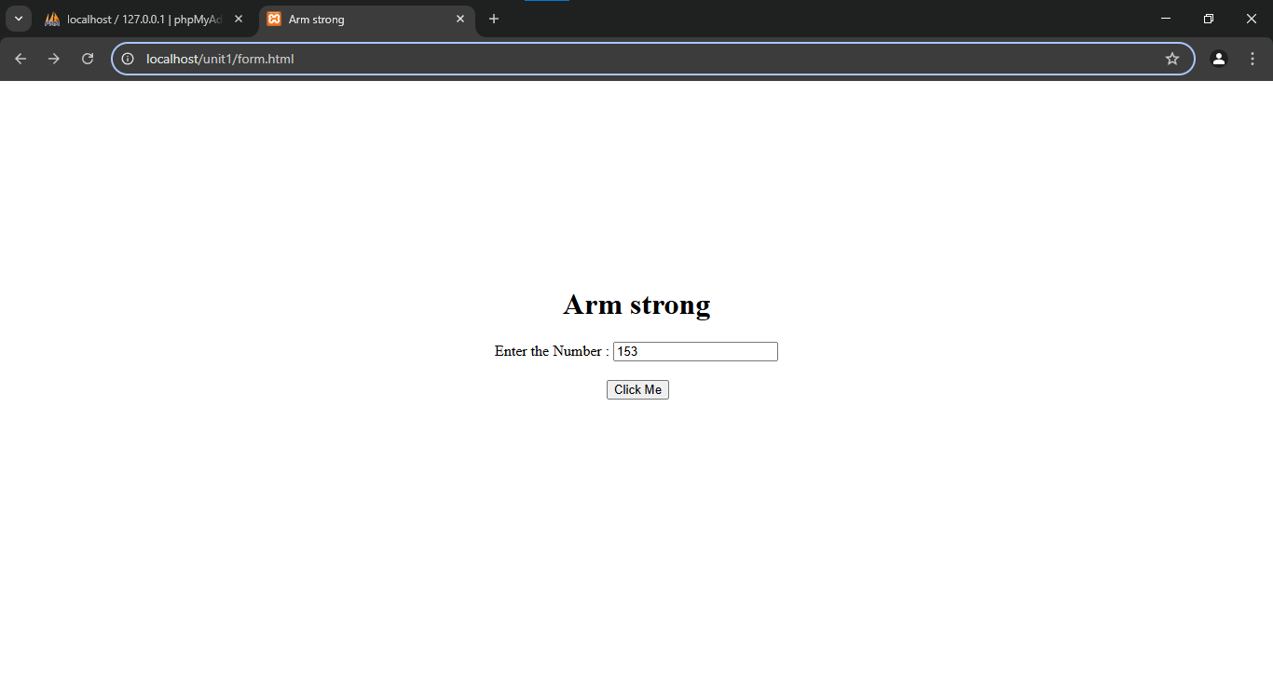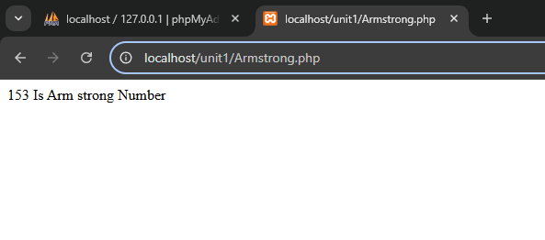

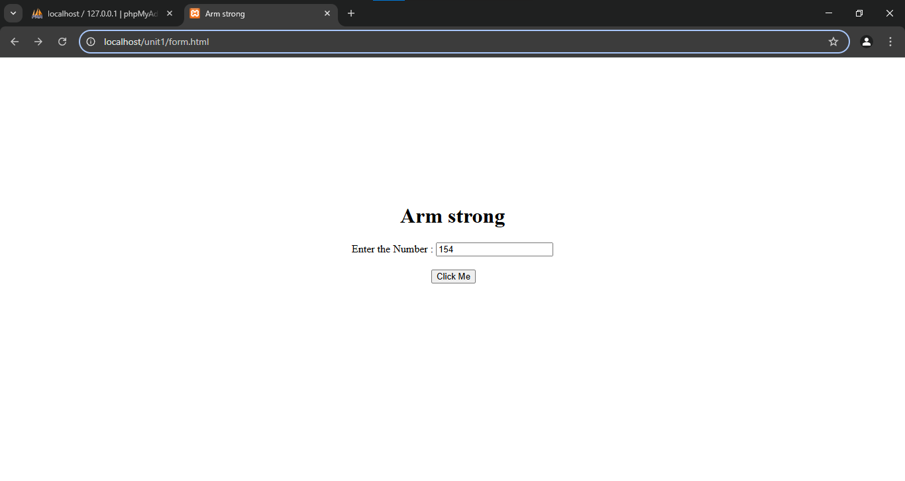

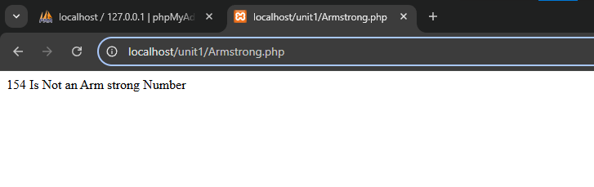

**Result:**

Thus, our program has been successfully saved and executed.

**GENERATE ARM STRONG**

**EX.NO : 06 010101**

**DATE :**

**AIM:**

To write a php program to generate the Arm Strong number upto the given number

**ALGORITHM:**

**Step 1:** Start the process

**Step 2:** Write the html5 program and create a form using text area and button control it performs the form action.

**Step 3:** When we click our button control it performs the form action.

**Step 4:** Write a php code and create a GenerateArmStrong.php file

**Step 5:** To generate Arm strong number upto the given number.

for($i=1;$i<=$v;$i++){

$sum = 0;

$j=$i;

while($j>0){

$r = $j%10;

$sum = $sum + ($r*$r*$r);

$j = $j/10;

}

if($i==$sum){

echo $sum." Is Arm strong Number";

echo "<br>";

}

}

**Step 6:** Save this program in the name of GenerateArmStrong.php and run using any web browser.

**Step 7:** Stop the process.

**form.html**

<!DOCTYPE html>

<html lang="en">

<head>

<meta charset="UTF-8">

<meta name="viewport" content="width=device-width, initial-scale=1.0">

<title>Generate Arm Strong</title>

<style>

.Heading{

display: flex;

flex-direction: column;

align-items: center;

margin-top: 200PX;

}

button{

align-items: center;

justify-content: center;

margin-left: 120px;

margin-top: 20px;

}

</style>

</head>

<body>

<div class="Heading">

<h1>Generate Arm Strong</h1>

<form action="GenerateArmStrong.php" method="post">

<label for="number">Enter the Number : </lable>

<input type = "text" name="number">

<br>

<button onClick="GenerateArmStrong.php">Click Me</button>

</form>

</div>

</body>

</html>

**GenerateArmStrong.php**

<?php

$v = $_POST["number"];

$c = $v;

$r = 0;

for($i=1;$i<=$v;$i++){

$sum = 0;

$j=$i;

while($j>0){

$r = $j%10;

$sum = $sum + ($r*$r*$r);

$j = $j/10;

}

if($i==$sum){

echo $sum." Is Arm strong Number";

echo "<br>";

}

}

?>

**Output:**

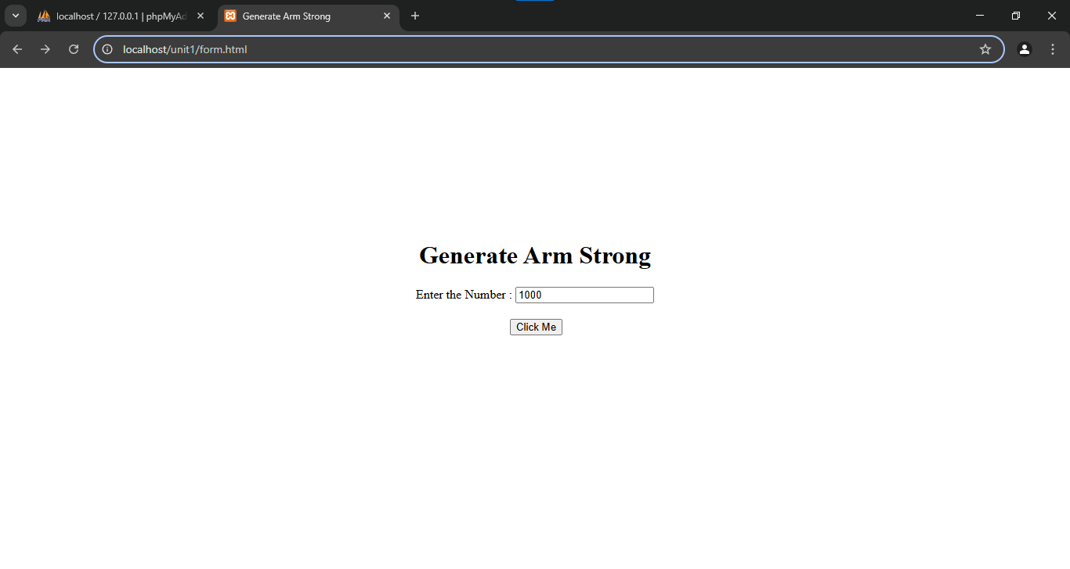

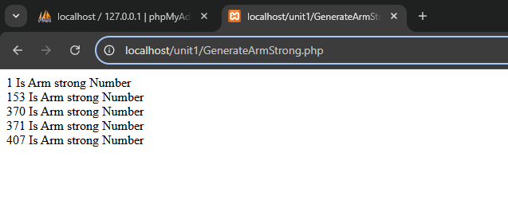

**Result:**

Thus, our program has been successfully saved and executed.

**PRODUCT OF THE PRIME**

**EX.NO : 07 010101**

**DATE :**

**AIM:**

To write a php program to generate the product of the prime for the given number

**ALGORITHM:**

**Step 1:** Start the process

**Step 2:** Write the html5 program and create a form using text area and button control it performs the form action.

**Step 3:** When we click our button control it performs the form action.

**Step 4:** Write a php code and create a ProductofPrime.php file

**Step 5:** To generate product of prime number for the given number.

$i=2;

while($v!=1){

if($v%$i==0){

echo $i.",";

$v=$v/$i;

}

else{

$i=$i+1;

}

}

**Step 6:** Save this program in the name of ProductofPrime.php and run using any web browser.

**Step 7:** Stop the process.

**form.html**

<!DOCTYPE html>

<html lang="en">

<head>

<meta charset="UTF-8">

<meta name="viewport" content="width=device-width, initial-scale=1.0">

<title>Product of Prime</title>

<style>

.Heading{

display: flex;

flex-direction: column;

align-items: center;

margin-top: 200PX;

}

button{

align-items: center;

justify-content: center;

margin-left: 120px;

margin-top: 20px;

}

</style>

</head>

<body>

<div class="Heading">

<h1>Product of Prime </h1>

<form action="ProductofPrime.php" method="post">

<label for="number">Enter the Number : </lable>

<input type = "text" name="number">

<br>

<button onClick="ProductofPrime.php">Click Me</button>

</form>

</div>

</body>

</html>

**ProductofPrime.php**

<?php

$v=$_POST["number"];

$i=2;

while($v!=1){

if($v%$i==0){

echo $i.",";

$v=$v/$i;

}

else{

$i=$i+1;

}

}

?>

**Output:**

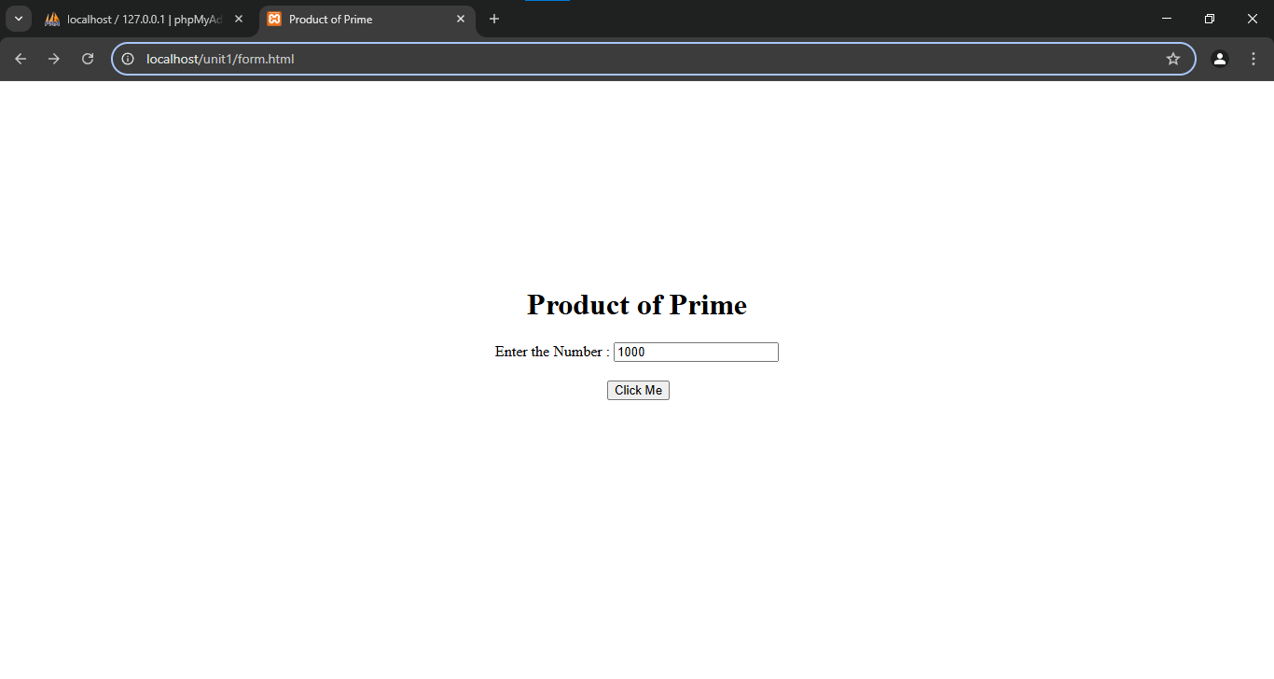

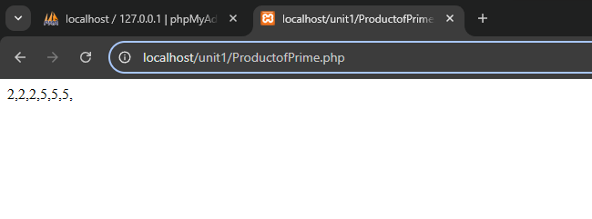

**Result:**

Thus, our program has been successfully saved and executed.

**DATE :**

**EX.NO : 08 010101**

**COLLATZE SEQUENCE**

**AIM:**

To write a php program to generate collatze sequence for the given number

**ALGORITHM:**

**Step 1:** Start the process.

**Step 2:** Write the html5 program and create a form using text area and button control it performs the form action.

**Step 3:** When we click our button control it performs the form action.

**Step 4:** Write a php code and create a collatzsequence.php file

**Step 5:** To generate collatzsequence number for the given number.

while($v != 1){

if($v % 2 == 0){

$v = $v/2;

echo $v.",";

}

else{

$v= 3 * $v + 1;

echo $v.",";

}

}

**Step 6:** Save this program in the name of collatzsequence.php and run using any web browser.

**Step 7:** Stop the process.

**form.html**

<!DOCTYPE html>

<html lang="en">

<head>

<meta charset="UTF-8">

<meta name="viewport" content="width=device-width, initial-scale=1.0">

<title>collatzsequence</title>

<style>

.Heading{

display: flex;

flex-direction: column;

align-items: center;

margin-top: 200PX;

}

button{

align-items: center;

justify-content: center;

margin-left: 120px;

margin-top: 20px;

}

</style>

</head>

<body>

<div class="Heading">

<h1>collatzsequence</h1>

<form action="collatzsequence.php" method="post">

<label for="number">Enter the Number : </lable>

<input type = "text" name="number">

<br>

<button onClick="collatzsequence.php">Click Me</button>

</form>

</div>

</body>

</html>

**collatzsequence.php**

<?php

$v=$_POST["number"];

while($v!=1){

if($v%2==0){

$v=$v/2;

echo $v.",";

}

else{

$v=3* $v+1;

echo $v.",";

}

}

?>

**Output:**

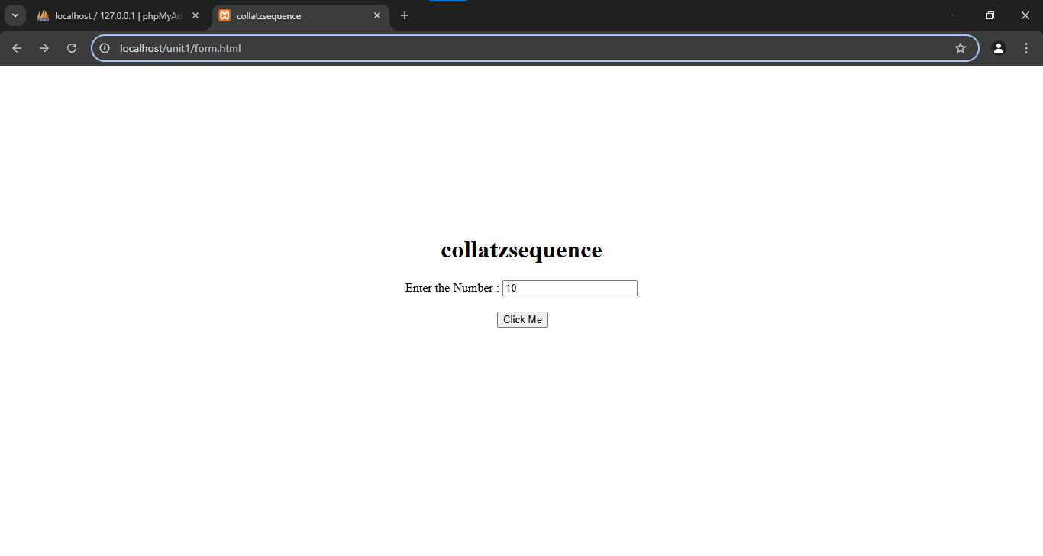

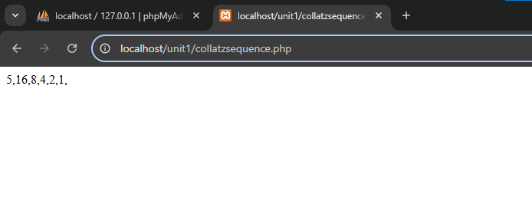

**Result:**

Thus, our program has been successfully saved and executed.

**DATE :**

**EX.NO : 09 010101**

**AMICABLE NUMBERS**

**AIM:**

To write a php program to generate collatze sequence for the given number

**ALGORITHM:**

**Step 1:** Start the process.

**Step 2:** Write the html5 program and create a form using text area and button control it performs the form action.

**Step 3:** When we click our button control it performs the form action.

**Step 4:** Write a php code and create a AmicableNumbers.php file.

**Step 5:** To check the given number is Amicable Number or not.

$sum=0;

$sum_of_sum = 0;

for($i=1;$i<$v;$i++){

if($v%$i==0){

$sum = $sum+$i;

}

}

for($i=1;$i<$sum;$i++){

if($sum%$i==0){

$sum_of_sum = $sum_of_sum+$i;

}

}

if($sum_of_sum == $v){

echo $v." is Amicable Number";

}

else{

echo $v." is No Amicable Numbers";

}

**Step 6:** Save this program in the name of AmicableNumbers.php and run using any web browser.

**Step 7:** Stop the process.

**form.html**

<!DOCTYPE html>

<html lang="en">

<head>

<meta charset="UTF-8">

<meta name="viewport" content="width=device-width, initial-scale=1.0">

<title>Amicable Numbers</title>

<style>

.Heading{

display: flex;

flex-direction: column;

align-items: center;

margin-top: 200PX;

}

button{

align-items: center;

justify-content: center;

margin-left: 120px;

margin-top: 20px;

}

</style>

</head>

<body>

<div class="Heading">

<h1>Amicable Numbers</h1>

<form action="AmicableNumbers.php" method="post">

<label for="number">Enter the Number : </lable>

<input type = "text" name="number">

<br>

<button onClick="AmicableNumbers.php">Click Me</button>

</form>

</div>

</body>

</html>

**AmicableNumbers.php**

<?php

$v = $_POST["number"];

$sum=0;

$sum_of_sum = 0;

for($i=1;$i<$v;$i++){

if($v%$i==0){

$sum = $sum+$i;

}

}

for($i=1;$i<$sum;$i++){

if($sum%$i==0){

$sum_of_sum = $sum_of_sum+$i;

}

}

if($sum_of_sum == $v){

echo $v." is Amicable Number";

}

else{

echo $v." is No Amicable Numbers";

}

?>

**Output:**

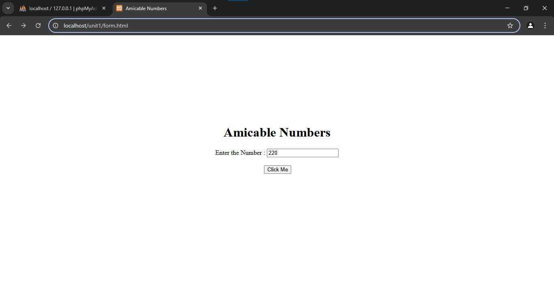

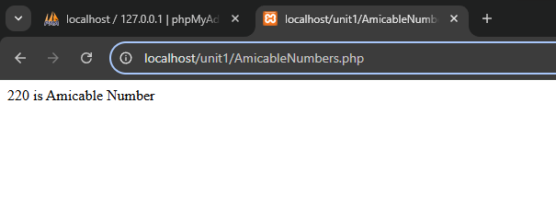

**Result:**

Thus, our program has been successfully saved and executed.

**CO-PRIME NUMBERS**

**EX.NO : 10 010101**

**DATE :**

**AIM:**

To write a php program to check the given numbers are co-prime or not

**ALGORITHM:**

**Step 1:** Start the process.

**Step 2:** Write the html5 program and create a form using text area and button control it performs the form action.

**Step 3:** When we click our button control it performs the form action.

**Step 4:** Write a php code and create a coprime.php file.

**Step 5:** To check the given two numbers are co-prime or not.

function gcd($a, $b) {

while ($b != 0) {

$temp = $b;

$b = $a % $b;

$a = $temp;

}

return $a;

}

function areCoPrime($num1, $num2) {

if (gcd($num1, $num2) == 1) {

return true;

}

return false;

}

**Step 6:** Save this program in the name of coprime.php and run using any web browser.

**Step 7:** Stop the process.

**coprimeformdesign. html**

<!DOCTYPE html>

<html lang="en">

<head>

<meta charset="UTF-8">

<meta name="viewport" content="width=device-width, initial-scale=1.0">

<title>co-prime</title>

<style>

.Heading{

display: flex;

flex-direction: column;

align-items: center;

margin-top: 200PX;

}

button{

align-items: center;

justify-content: center;

margin-left: 120px;

margin-top: 20px;

}

</style>

</head>

<body>

<div class="Heading">

<h1>co-prime</h1>

<form action="coprime.php" method="post">

<label for="num1">Enter the Num1 : </lable>

<input type = "text" name="num1">

<label for="num2">Enter the Num2 : </lable>

<input type = "text" name="num2">

<br>

<button onClick="coprime.php">Click Me</button>

</form>

</div>

</body>

</html>

**coprime.php**

<?php

function gcd($a, $b) {

while ($b != 0) {

$temp = $b;

$b = $a % $b;

$a = $temp;

}

return $a;

}

function areCoPrime($num1, $num2) {

if (gcd($num1, $num2) == 1) {

return true;

}

return false;

}

if (isset($_POST["num1"]) && isset($_POST["num2"])) {

$num1 = $_POST["num1"];

$num2 = $_POST["num2"];

if (areCoPrime($num1, $num2)) {

echo "$num1 and $num2 are co-prime.";

} else {

echo "$num1 and $num2 are not co-prime.";

}

} else {

echo "Please provide two numbers via URL (e.g., ?num1=5&num2=9)";

}

?>

**Output:**

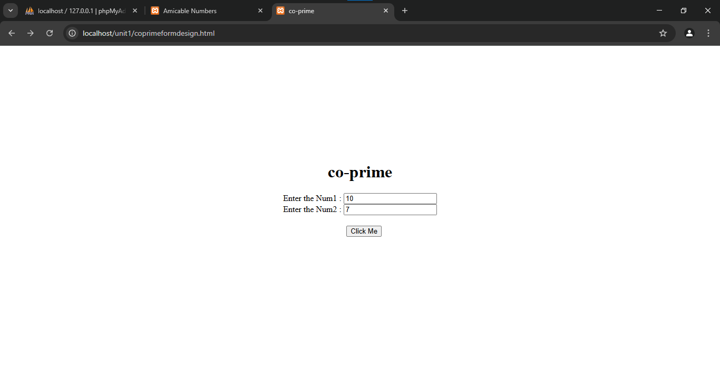

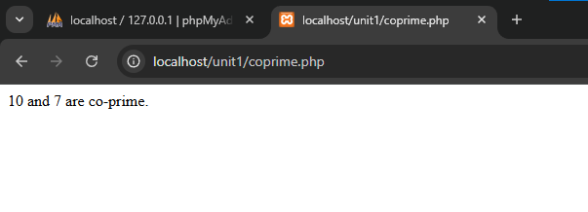

**Result:**

Thus, our program has been successfully saved and executed.

**EVEN FIBONACCI NUMBERS**

**EX.NO : 11 010101**

**DATE :**

**AIM:**

To write a php program to sum of the even fibonacci numbers for the given numbers.

**ALGORITHM:**

**Step 1:** Start the process.

**Step 2:** Write the html5 program and create a form using text area and button control it performs the form action.

**Step 3:** When we click our button control it performs the form action.

**Step 4:** Write a php code and create a EvenFibonacci.php file.

**Step 5:** To sum of the even fibonacci numbers for the given numbers.

while ($b <= $limit) {

if ($b % 2 == 0) {

$sum += $b;

}

$next = $a + $b;

$a = $b;

$b = $next;

}

**Step 6:** Save this program in the name of EvenFibonacci.php and run using any web browser.

**Step 7:** Stop the process.

**form.html**

<!DOCTYPE html>

<html lang="en">

<head>

<meta charset="UTF-8">

<meta name="viewport" content="width=device-width, initial-scale=1.0">

<title>Even fibonacci</title>

<style>

.Heading{

display: flex;

flex-direction: column;

align-items: center;

margin-top: 200PX;

}

button{

align-items: center;

justify-content: center;

margin-left: 120px;

margin-top: 20px;

}

</style>

</head>

<body>

<div class="Heading">

<h1>Even fibonacci</h1>

<form action="Evenfibonacci.php" method="post">

<label for="number">Enter the Number : </lable>

<input type = "text" name="number">

<br>

<button onClick="Evenfibonacci.php">Click Me</button>

</form>

</div>

</body>

</html>

**Evenfibonacci.php**

<?php

function evenFibonacciNumbers($limit) {

$a = 0;

$b = 1;

$sum = 0;

while ($b <= $limit) {

if ($b % 2 == 0) {

$sum += $b;

}

$next = $a + $b;

$a = $b;

$b = $next;

}

return $sum;

}

$limit = $_POST["number"];

echo "The Number of Sum of even Fibonacci numbers is $limit: " . evenFibonacciNumbers($limit) . "\n";

?>

**Output:**

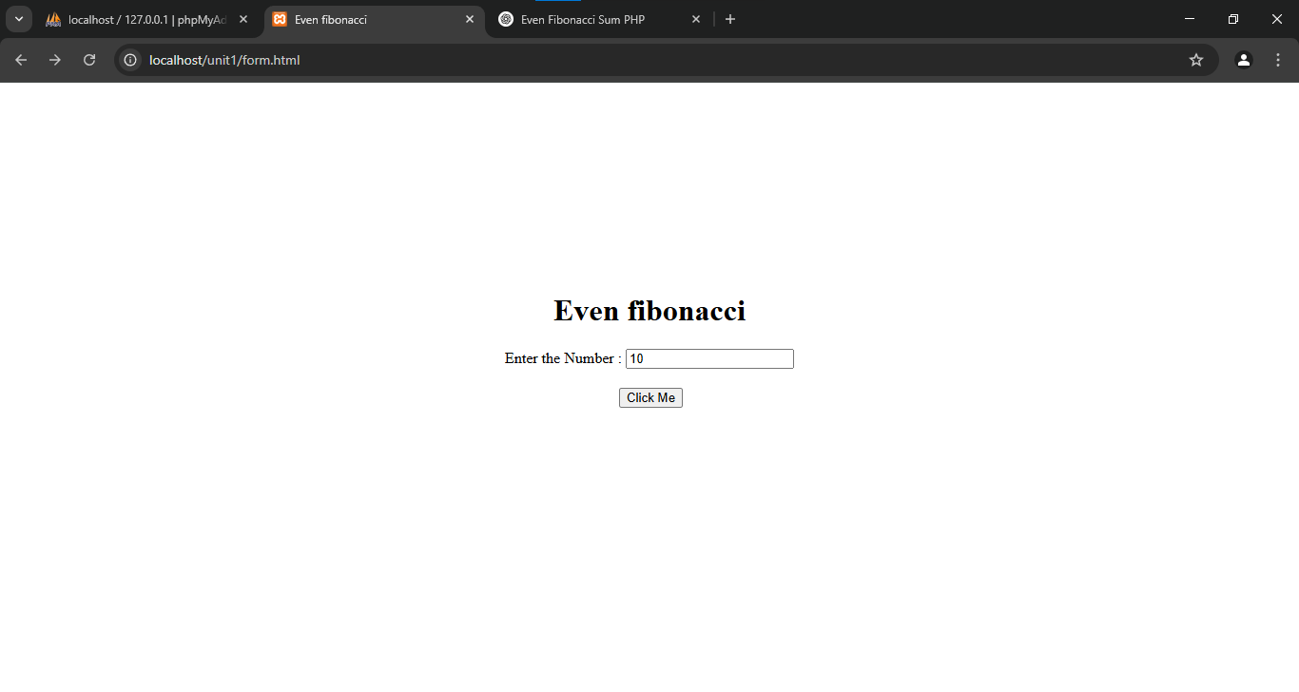

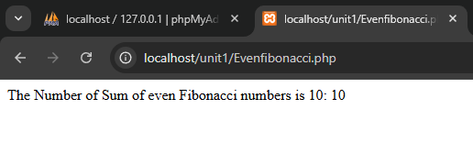

**Result:**

Thus, our program has been successfully saved and executed.

**DATE :**

**EX.NO : 12 010101**

**SINGLE DIGIT**

**AIM:**

To write a php program to convert the given numbers into single digit number.

**ALGORITHM:**

**Step 1:** Start the process.

**Step 2:** Write the html5 program and create a form using text area and button control it performs the form action.

**Step 3:** When we click our button control it performs the form action.

**Step 4:** Write a php code and create a single.php file.

**Step 5:** To convert the given number into single digit.

while ($number >= 10) {

$number = array_sum(str_split($number));

}

**Step 6:** Save this program in the name of single.php and run using any web browser.

**Step 7:** Stop the process.

**form.html**

<!DOCTYPE html>

<html lang="en">

<head>

<meta charset="UTF-8">

<meta name="viewport" content="width=device-width, initial-scale=1.0">

<title>Single Digit</title>

<style>

.Heading{

display: flex;

flex-direction: column;

align-items: center;

margin-top: 200PX;

}

button{

align-items: center;

justify-content: center;

margin-left: 120px;

margin-top: 20px;

}

</style>

</head>

<body>

<div class="Heading">

<h1>Convert the Given Numbers into Single Digit</h1>

<form action="single.php" method="post">

<label for="number">Enter the Number : </lable>

<input type = "text" name="number">

<br>

<button onClick="single.php">Click Me</button>

</form>

</div>

</body>

</html>

**single.php**

<?php

function reduceToSingleDigit($number) {

while ($number >= 10) {

$number = array_sum(str_split($number));

}

return $number;

}

$number = $_POST["number"];

echo "The Given Number $number : " . reduceToSingleDigit($number);

?>

**Output:**

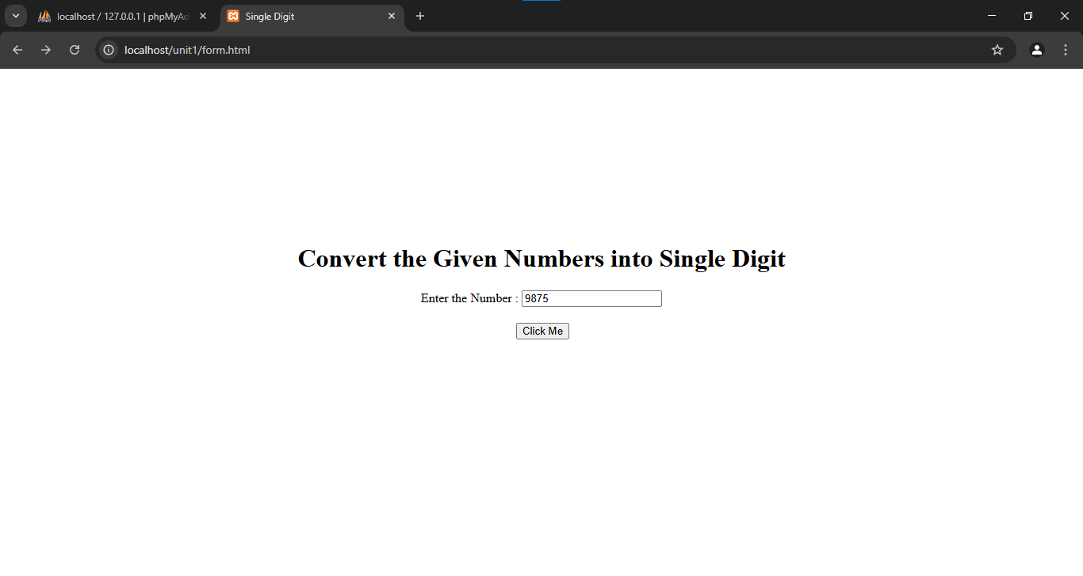

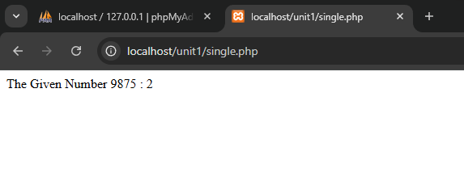

**Result:**

Thus, our program has been successfully saved and executed.